1.Armstrong number
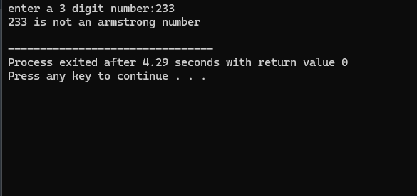

2.search element of the list
Enter the number of elements: 23
Enter the element to search: 2
Enter element 1: 1
Enter element 2: 3
Enter element 3: 2
Element 2 found at position 3.
3.compare intger
Enter the number of integers to compare: 2
Enter integer 1: 234
Enter integer 2: 346
The largest integer is: 346
The smallest integer is: 234

--------------------------------
Process exited after 8.198 seconds with return value 0
Press any key to continue . . .

4.divisible 3
The sum of all numbers between 1000 and 2000 divisible by 3 is: 499500

--------------------------------
Process exited after 1.203 seconds with return value 0
Press any key to continue . . .
5.AP and GB
Enter the first term (a): 1
Enter the number of terms (n): 2
Enter the common difference for AP (d): 12
Enter the common ratio for GP (r): 2

Arithmetic Progression (AP) Series:
1.00 13.00

Geometric Progression (GP) Series:
1.00 2.00
6. pattern
#include <stdio.h>
int main() {
int n = 5;
for (int i = n; i >= 1; i--) {
for (int j = 1; j <= i; j++) {
printf("*");
}
printf("\n");
}
return 0;
}
*****
****
***
**
*
#include <stdio.h>
int main() {
int n = 5, count = 1;
for (int i = 1; i <= n; i++) {
for (int j = 1; j <= i; j++) {
printf("%d ", count);
count++;
}
printf("\n");
}
return 0;
}
1
2 3
4 5 6
7 8 9 10
11 12 13 14 15
#include <stdio.h>
int main() {
int n = 5;
for (int i = 1; i <= n; i++) {
for (int j = 1; j <= i; j++) {
printf("%d ", j);
}
printf("\n");
}
return 0;
}
1
1 2
1 2 3
1 2 3 4
1 2 3 4 5
#include <stdio.h>
int main() {
int n = 5;
for (int i = 1; i <= n; i++) {
for (int j = 1; j <= i; j++) {
printf("*");
}
printf("\n");
}
return 0;
}
*
**
***
****
#include <stdio.h>
int main() {
int rows = 5;
int num = 1;
for (int i = 1; i <= rows; i++) {
// Print leading spaces
for (int j = i; j < rows; j++) {
printf(" ");
}
// Print numbers
for (int j = 1; j <= i; j++) {
printf("%d ", num);
num++;
}
// Move to the next line
printf("\n");
}
return 0;
}
1
2 3
4 5 6
7 8 9 10
11 12 13 14 15
#include <stdio.h>
int main() {
int rows = 5;
for (int i = 1; i <= rows; i++) {
// Print stars
for (int j = 1; j <= i; j++) {
printf("*");
}
// Move to the next line
printf("\n");
}
return 0;
}*
**
***
****
#include <stdio.h>
int main() {
int rows = 5;
for (int i = 1; i <= rows; i++) {
// Print leading spaces
for (int j = i; j < rows; j++) {
printf(" ");
}
// Print stars
for (int j = 1; j <= (2 * i - 1); j++) {
printf("*");
}
// Move to the next line
printf("\n");
}
return 0;
}
*
***
*****
*******
#include <stdio.h>
int main() {
int rows = 5;
for (int i = rows; i >= 1; i--) {
for (int j = 1; j <= i; j++) {
printf("*");
}
printf("\n");
}
return 0;
}
*****
****
***
**
*
7.#include <stdio.h>
int main() {
int num, originalNum, reversedNum = 0, remainder;
// Input the number to check
printf("Enter an integer: ");
scanf("%d", &num);
// Store the original number
originalNum = num;
// Reverse the number
while (num != 0) {
remainder = num % 10;
reversedNum = reversedNum * 10 + remainder;
num /= 10;
}
// Check if the original number is equal to the reversed number
if (originalNum == reversedNum) {
printf("%d is a palindrome.\n",
originalNum); } else {
printf("%d is not a palindrome.\n", originalNum);
}
return 0;
}
Enter an integer: 101
101 is a palindrome.

8.menu driven
Menu:
1. Addition
2. Subtraction
3. Multiplication
4. Division
5. Exit
Enter your choice (1-5): 2+3
Enter two numbers: 23
Result: -20.00

